Lubrication and Vulva/Vagina Moisturizers
Pebble Kranz, MD, FECSM
When the skin of the vulva and the vagina get less estrogen and testosterone than they are used to, this skin gets dry and uncomfortable for many women. The thickness of the skin and the supporting tissues beneath it get thinner and more easily injured. Also, the pH of the vagina changes without estrogen. (The pH is normally between 4.5 and 5.5 when adequate estrogen is present.) The vulvar vestibule—the skin on the inside of the labia minora but outside of the opening to the vagina—the clitoris, and the urethra (where urine exits the body) are all filled with androgen (or testosterone) receptors. This area can become either painful or less pleasurable when there is less testosterone available.

Moisturizers for vaginal and vulvar skin are just like moisturizers for the rest of your body—they should be used regularly to keep skin healthy and strong. And dry, uncomfortable skin is unpleasant anywhere it happens. Use of vaginal moisturizers can also decrease urinary frequency and urgency, urinary tract infections (UTIs) and vaginal infections like yeast and bacterial vaginosis (BV). And, sometimes it can even increase desire.

Sexual lubricants are used for sexual play. They can be helpful with any kind of sexual play, but especially with any kind of penetration. Using lubrication for sex doesn’t mean you are not aroused, or that you aren’t attracted to your partner. It’s like making sure your oil tank is full of nice clean oil in order to be sure you have a smooth and worry-free joy-ride.

So where do you start in picking a moisturizer or a sexual lubricant?

I wish this were easier. Moisturizers available in the drugstore either have too low a pH (Replens) or they haven’t published the studies to indicate what the pH is (Luvena). And many of them have ingredients that experts recommend avoiding. Primarily, this is a matter of personal experimentation to find the one that works for you.

Some of the moisturizers recommended by ISSWSH (the International Society for the Study of Women’s Sexual Health) are Replens, RepHresh, Yes, HyaloGyn, Liquid Silk, Sliquid Organics Silk, Sync Erosense.
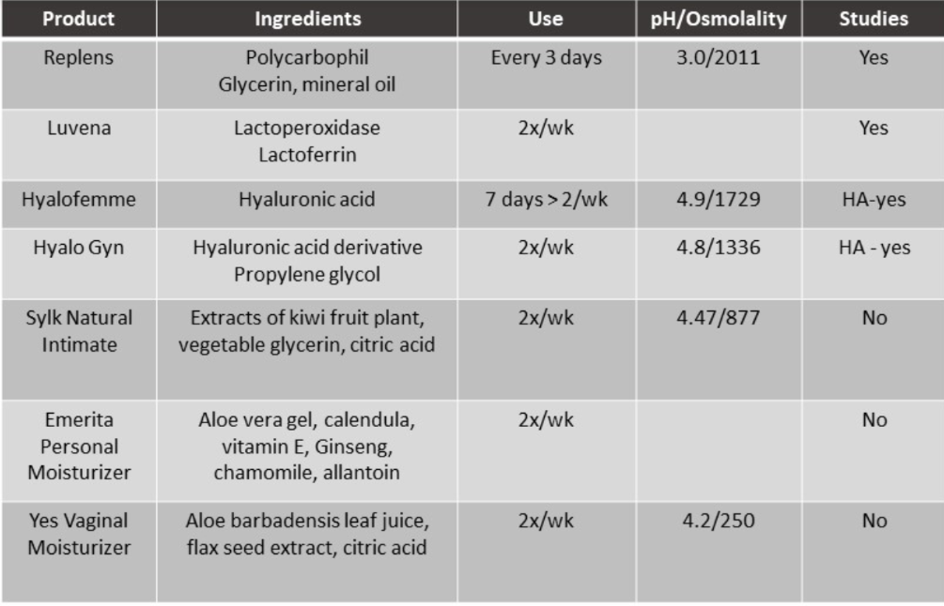

Silicone lubricants are best when you need things to be really slippery for a long time. They are also good when genitals are very sensitive to friction. They work well for anal play. They’re compatible with all kinds of condoms. Silicone lubes last longer than water-based ones. Do not use silicone lube with silicone sex toys—the silicone lube will break down the silicone of the toy. If your partner has erection difficulties, silicone lubricants may reduce friction so much that it is hard for them to maintain an erection. Some good silicone lubes: UberLube, Pink, Pjur, ID Millenium.

Water-based lubricants can be used with latex condoms and all sex toys, but that may dry up quickly. Some good ones include: Sliquid Organic, Good Clean Love, Liquid Silk, and Pre-Seed. Extra caution is advised when choosing a water based lubricant from the pharmacy—the ones most commonly found in drugstores, such as K-Y Jelly and Astroglide have ingredients that can irritate the vulva and vagina, worsen pelvic pain conditions, damage the cells of the vagina and rectum and lead to infections.

Lube experts advise against using lubes with the following ingredients:
- Glycerin
- Propylene glycol
- Chlorhexidine gluconate
- Polyquaternium-15
- Parabens
- Mineral oil
- Petrolatum (petroleum jelly)
Ellen Barnard of A Woman’s Touch recommends choosing lubricants with one or more of these ingredients (she suggests testing any lubricant on the inside of your arm first if you tend to be sensitive):
- Aloe vera, which is moisturizing – but if you’re allergic to onions or garlic, avoid Aloe vera.
- Hyaluronic Acid, a moisturizing ingredient, but not very slippery.
- Plant cellulose (it may be called hydroxyethylcellulose or cellulose polymer), which makes lubes slippery and moisturizing, and adds body.
- Vitamin E, a good skin conditioner, but too waxy to use on its own.
- Dimethicone or dimethiconol, a good sealant to keep moisture in and protect from tearing.

Hybrid lubes, a blend of water-based and silicone, are also available. They’re safe with condoms and usually are compatible with silicone sex toys, too. Hybrids last longer than regular water-based lubricants and are more likely to stay slick. An option: Sliquid Silk.

Special situations
If you are prone to bacterial vaginosis or yeast infections, avoid the following ingredients: glycerin, parabens, propylene glycol, and sensation gimmicks. Also use caution when using food oils for lubrication or moisturizing. They may encourage the growth of bacteria in the vagina and don’t flush out easily. Olive oil and unrefined coconut oil may be the exceptions – many people report enjoying them without ill effects. Food oils may cause breakage of condoms and other barriers.

If you are working on becoming pregnant, be aware that lubes may have an impact on sperm motility. A specially formulated lube like Pre-seed may be useful.

It’s a good idea to explore different lubes by buying samples so you can discover which work best for you. Several good resources have sampler kits: Smitten Kitten, A Woman’s Touch
Other options exist:
- Topical Estrogen—in vaginal pill, ring, or cream form.
- Vaginal DHEA (IntraRosa)
- Ospemifene
- Fractional Laser CO2 (eg MonaLisa Touch)
Vibrators: Good for sexual satisfaction, blood flow, health of the pelvic floor. 53% of women use them. Get a high quality vibrator made from silicone for both internal and external use. Clean with soap and water. Don’t switch between body areas—a vaginal vibrator doesn’t go in the anus or vice versa—and don’t share with others.

